Week 7 Internship Documentation
Infosys Springboard Internship | Data Visualization Domain
Topic Focus: DAX Practical Implementation, Advanced Report Features, and Dashboard Storytelling
Prepared by: Hindu Priya Boddu
Project: Optimizing IT Support Team Performance Using Analytics


1. Introduction
During Week 7 of the internship, the focus moved from theoretical modeling concepts to practical implementation in Power BI. This week concentrated on DAX from basic to advanced level, creation of core KPIs, and the use of advanced report features such as slicers, drill-through, tooltips, page navigation, bookmarks, visual interactions, and dashboard storytelling. This stage is highly important because it transforms a cleaned and modeled dataset into a business-ready analytical dashboard.
For the project 'Optimizing IT Support Team Performance Using Analytics,' Week 7 plays a major role because the selected KPIs and DAX measures now become visible insights for decision-makers. The report design and interaction features ensure that the dashboard is not only technically correct but also easy to understand, easy to explore, and useful for business action.

2. DAX Basics to Advanced – Practical Understanding
DAX (Data Analysis Expressions) is the analytical formula language of Power BI. In practical dashboard development, DAX is used to create measures, calculated columns, and advanced business logic that dynamically responds to slicers, filters, drill-downs, and report context.
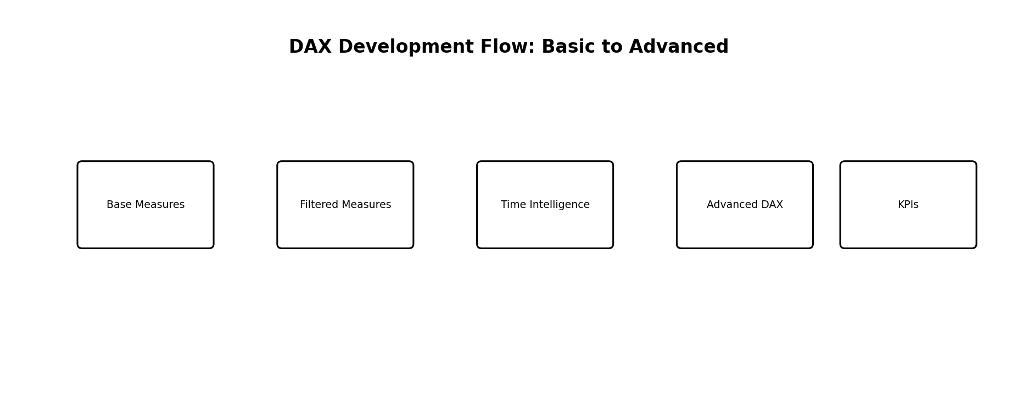
Figure 1: DAX development journey from basic measures to advanced KPI logic

2.1 DAX Basics
- Simple aggregations such as COUNT, SUM, AVERAGE, MIN, and MAX
- Basic logical conditions using IF and SWITCH
- Simple filtered calculations using CALCULATE
- Safe division using DIVIDE
- Text or label support using FORMAT

2.2 Intermediate DAX
- Filtered measures using CALCULATE with conditions
- Using DISTINCTCOUNT for unique customer analysis
- Using ALL and ALLEXCEPT for comparison logic
- Creating percentage KPIs with DIVIDE
- Using FILTER for custom table filters

2.3 Advanced DAX
- Iterator functions such as SUMX, AVERAGEX, COUNTX
- Advanced context handling with CALCULATE
- Context transition concepts
- Time intelligence functions with a Date table
- Ranking and segmentation logic using RANKX (conceptual advanced topic)
- Dynamic titles and selected value logic using SELECTEDVALUE
- Conditional formatting support measures

3. Measures vs Calculated Columns
Aspect | Measure | Calculated Column
Nature | Dynamic calculation | Stored row-level calculation
Evaluation Time | At query time / visual time | At refresh time
Best Use | KPIs, dynamic metrics, percentages | Flags, categories, row labels
Model Size | Usually lighter | Can increase model size
Context | Filter context | Row context
Recommendation | Preferred for dashboards | Use only when row-level logic is needed
For this project, most important business metrics such as Total Tickets, Closed Tickets, Average Resolution Time, SLA Breach Rate, and Escalation Rate should be created as measures rather than calculated columns.

4. Core KPI Creation for the Student Perfomance Analysis Project
The dashboard should include a set of executive and operational KPIs. These KPIs should be created as reusable DAX measures so they can be used consistently across multiple pages and visuals.
KPI | Suggested DAX Logic (Conceptual) | Business Meaning
Total Students | COUNT(Student ID) | Shows total number of students in the dataset. Helps understand dataset size.
Average Math Score | AVERAGE(Math Score) | Indicates overall performance in mathematics across all students.
Average Reading Score | AVERAGE(Reading Score) | Shows how students perform in reading skills.
Average Writing Score | AVERAGE(Writing Score) | Reflects students’ writing performance level.
Overall Average Score % | (Avg Math + Avg Reading + Avg Writing) / 3 | Gives a combined performance indicator across all subjects.
Students Completed Test Prep (%) | COUNT(Test Prep = "Completed") / Total Students | Measures how many students completed preparation courses.
Students Not Completed Test Prep (%) | COUNT(Test Prep = "Not Completed") / Total Students | Identifies students who did not take preparation, useful for comparison.
Average Score by Gender | AVERAGE(Score) grouped by Gender | Helps compare performance between male and female students.
Average Score by Ethnicity | AVERAGE(Score) grouped by Ethnicity | Shows if there are performance differences across ethnic groups.
Average Score by Parental Education | AVERAGE(Score) grouped by Parental Education | Helps understand how parent education level impacts student performance.
Top 5 Students | TOPN(5, Students, Total Score) | Identifies highest-performing students based on combined scores.
Total Score per Student | Math + Reading + Writing | Used to rank students and evaluate overall performance individually.
Performance Gap (Prep vs No Prep) | Avg Score (Completed) - Avg Score (Not Completed) | Shows impact of test preparation on performance.
Highest Score Achieved | MAX(Math, Reading, Writing) | Identifies peak performance level among students.
Lowest Score Achieved | MIN(Math, Reading, Writing) | Helps identify struggling students or lowest performance level.

5. Time Intelligence Basics
Time intelligence is one of the most important advanced DAX topics. It allows analysts to compare performance across days, months, quarters, and years. Even if the current project is simple, understanding time intelligence is highly valuable for professional dashboarding.
- Requires a proper Date table
- Date table should be marked as a Date Table in Power BI
- Useful for trend analysis, month-wise performance, and period comparison
Time Intelligence Function | Purpose
TOTALYTD | Calculate year-to-date totals
DATEADD | Shift date context backward or forward
SAMEPERIODLASTYEAR | Compare with same period last year
PREVIOUSMONTH | Analyze previous month performance
DATESMTD / DATESYTD | Month-to-date and year-to-date ranges
For this project, time intelligence can be applied to ticket volume trends, monthly SLA breaches, monthly average response time, and month-wise satisfaction trends using ticket_created_date or a dedicated Date table.

6. Advanced DAX Topics Useful in Real Dashboards
Advanced Topic | Use in This Project
CALCULATE | Apply business filters for status, priority, SLA, escalation
FILTER | Create custom filtered logic
ALL / ALLEXCEPT | Compare current selection with total or preserve specific grouping
SELECTEDVALUE | Dynamic titles and context-aware labels
ISFILTERED / HASONEVALUE | Control display logic based on filter state
RANKX | Rank products, regions, or categories by ticket count
SUMX / AVERAGEX | Row-by-row advanced aggregations
VAR | Improve readability and performance in complex measures
COALESCE | Handle blanks gracefully in measures
KEEPFILTERS | Preserve filter behavior in advanced calculations

7. Slicers
Slicers are interactive filter controls that allow users to dynamically explore the report. In a professional dashboard, slicers should be chosen carefully so they improve usability without making the page cluttered.
- Recommended slicers: Date, Region, Priority, Status, Channel, Product, Customer Segment, Subscription Type
- Use dropdown slicers when many values exist
- Use horizontal slicers for fewer values like Priority or Status
- Sync slicers across pages if business users need consistent filtering

8. Drill-through
Drill-through allows the user to right-click on a data point and move to a detailed page filtered for that specific item. This is very powerful in operational dashboards because it supports root-cause analysis.
- Create a dedicated drill-through page for Product details
- Create a drill-through page for Region analysis
- Create a drill-through page for Customer Segment or Category
- Useful to move from summary KPI to detailed ticket-level patterns

9. Tooltips
Tooltips improve user experience by showing extra context when the user hovers over a visual. Report page tooltips are more advanced than default tooltips and allow a mini-report to appear on hover.
- Use tooltips to show extra KPIs without crowding the main page
- For product bars, show ticket count, avg resolution time, and satisfaction in tooltip
- For region charts, show SLA breach rate and escalation rate in tooltip
- Create a dedicated tooltip page for richer contextual information

10. Page Navigation
Page navigation helps create a professional app-like experience inside Power BI. Instead of manually switching pages, users can click buttons or shapes to move between report sections.
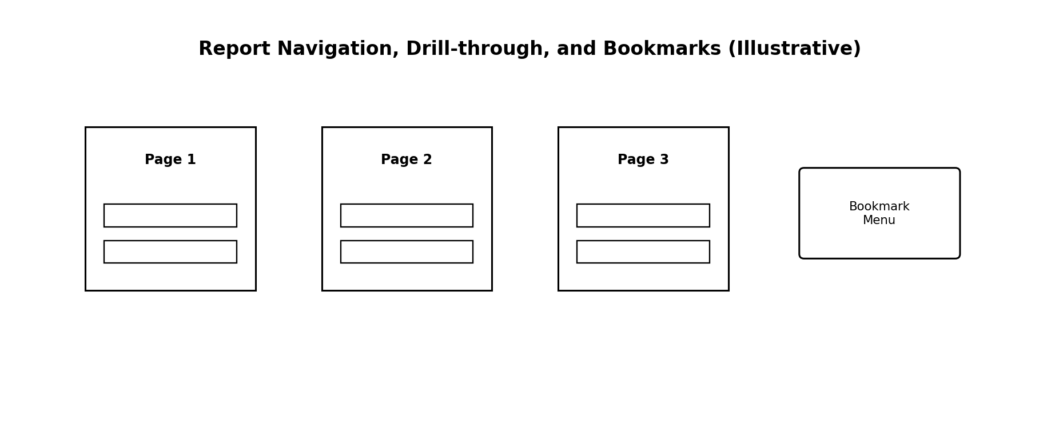
Figure 2: Page navigation, drill-through, and bookmark-based report interaction
- Use buttons for Executive Overview, Operations, and Customer Experience pages
- Add Home button on all pages
- Use consistent navigation placement for usability
- Use icons and labels for clarity

11. Bookmarks
Bookmarks save the current state of the report, including filters, visible objects, and page selections. They are useful for creating storytelling flows, show/hide panels, navigation menus, and guided analysis.
- Create bookmark-based navigation menu
- Use bookmarks to show/hide filter panel
- Use bookmarks for view switching (Summary View vs Detailed View)
- Use bookmarks to create presentation-style storytelling

12. Visual Interactions
Visual interactions define how one visual affects another when the user clicks a data point. Proper interaction settings improve clarity and prevent confusing report behavior.
- Use cross-filtering for related visuals
- Disable interactions where visuals should remain stable
- Avoid too many visuals filtering each other unnecessarily
- Test interaction logic carefully for user friendliness

13. Dashboard Formatting and Storytelling
A technically correct dashboard is not enough. It must also communicate insights clearly. Dashboard storytelling means arranging visuals in a logical order so the user understands what is happening, why it is happening, and what action should be taken.
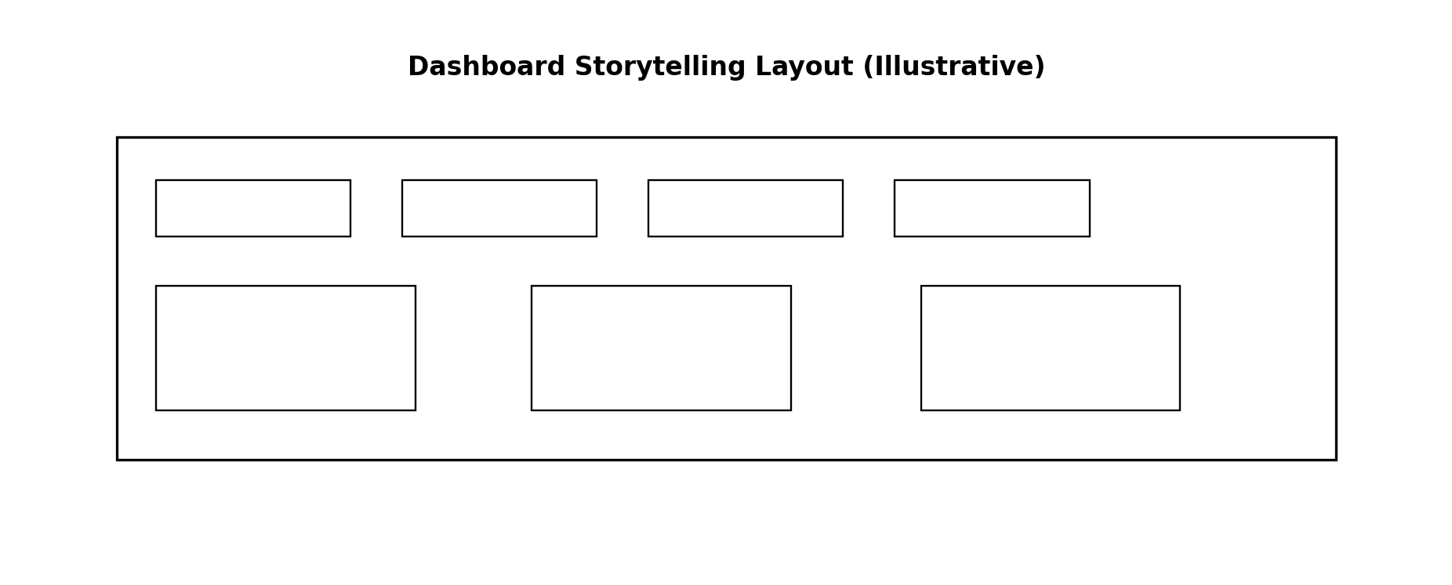
Figure 3: Example of a storytelling-oriented dashboard layout
- Top section: KPI cards for instant executive summary
- Middle section: trend and distribution visuals
- Bottom section: diagnostic visuals such as category, region, and channel comparisons
- Use consistent fonts, colors, spacing, and alignment
- Limit visual clutter and avoid too many chart types on one page
- Use titles that explain the business meaning, not only the technical metric

14. Recommended Multi-Page Dashboard Structure
- Page 1 – Executive Overview (KPI cards, ticket trends, status split, priority distribution)
- Page 2 – Operational Analysis (category, product, region, channel, SLA, escalation)
- Page 3 – Customer Experience (satisfaction, subscription type, segment, contact time, language)
- Page 4 – Drill-through Details (product or region-specific deeper analysis)
- Page 5 – Hidden Tooltip / Bookmark Support Pages

15. Other Advanced Topics Worth Mentioning
- Dynamic titles using SELECTEDVALUE
- Conditional formatting based on KPI thresholds
- KPI icons and color indicators
- Field parameters (advanced feature for switching metrics or dimensions conceptually)
- Measure branching for cleaner DAX development
- Using a dedicated Measures table
- Tooltip pages for micro-insights
- Sync slicers across pages
- Performance optimization by reducing unnecessary visuals and heavy calculations

16. Practical Workflow for Week 7
- Create base measures first
- Create filtered and percentage measures next
- Validate all KPIs in simple tables before using cards
- Build the first executive overview page
- Add slicers and sync important filters
- Create drill-through and tooltip pages
- Set up page navigation and bookmarks
- Adjust visual interactions
- Apply formatting and storytelling improvements
- Test the dashboard as if a business user is using it

17. Week 7 Learning Summary
Week 7 focused on the practical implementation of DAX and advanced report design in Power BI. The learning covered DAX from basic to advanced level, including measures, calculated columns, KPI creation, time intelligence basics, and advanced functions such as CALCULATE, FILTER, ALL, SELECTEDVALUE, VAR, and iterator functions. In addition, the report-building side covered slicers, drill-through, tooltips, page navigation, bookmarks, visual interactions, and dashboard storytelling.
This week is highly valuable because it transforms the analytical logic into a user-friendly business dashboard. It ensures that the report is not only technically strong but also interactive, navigable, and decision-oriented.

18. Conclusion
Week 7 is one of the most practical and impactful stages of the internship because it combines analytical calculations with professional report design. By implementing DAX measures, building KPI logic, and adding advanced Power BI features such as slicers, drill-through, tooltips, bookmarks, page navigation, and visual interactions, the dashboard becomes a complete analytical product. For the support ticket analytics project, this week helps convert raw metrics into an interactive and business-friendly decision support system.
